EXPERIMENT 8 — DOCUMENT CONTEXT
Ex. No.: 8
Title: Use StegExpose to Detect Hidden Data in Images
Date: __________
Aim
To use StegExpose to analyze digital images and detect possible hidden data using statistical steganalysis.
Objective
- To examine digital images for possible steganographic content.
- To analyze the statistical properties of the given images using StegExpose.
- To obtain the Fusion score for each image.
- To compare the obtained scores with the default steganographic detection threshold.
Software / Tools Required
- Java Runtime Environment (JRE)
- StegExpose
- Windows Command Prompt
- Test images
Procedure
Step 1: Verify Java Installation
Java installation was verified using the following command:
java -version
The installed Java environment was displayed successfully, confirming that Java was available for executing the StegExpose JAR file.
Screenshot 1 — Java version verification
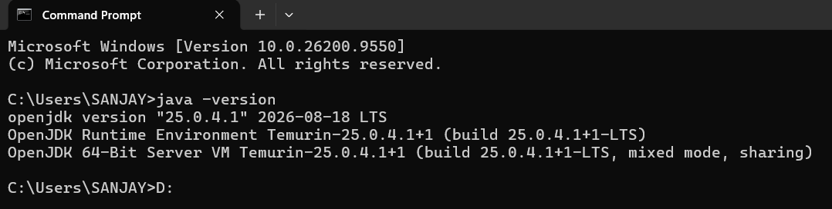

Step 2: Create the Experiment Directory
A separate directory was created on the D: drive for Experiment 8.
D:
mkdir DF_Experiment_8
cd DF_Experiment_8
The experiment directory used was:
D:\DF_Experiment_8
A subdirectory named testFolder was created to store the test images.
mkdir testFolder
The StegExpose JAR file and test images were placed in the experiment directory and testFolder, respectively.
Screenshot 2 — Experiment folder and test images
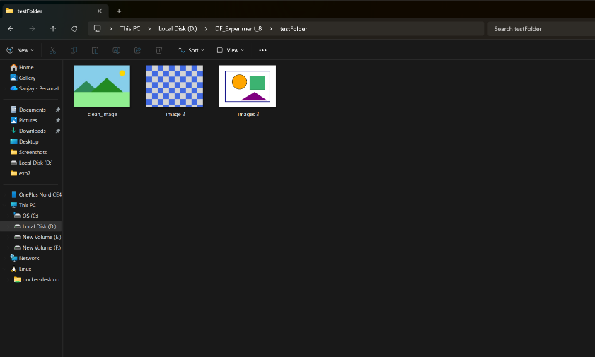
Step 3: Execute StegExpose
The StegExpose program was executed on the test image folder using:
java -jar StegExpose.jar testFolder
The command completed successfully without displaying an error.
Screenshot 3 — StegExpose execution
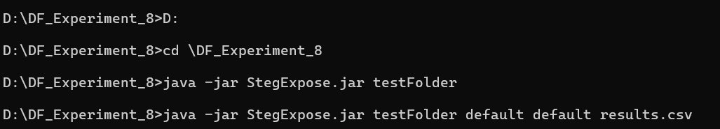Step 4: Generate the Steganalysis Results
To obtain detailed statistical results in CSV format, the following command was executed:
java -jar StegExpose.jar testFolder default default results.csv
The command generated the file:
results.csv
The results were then displayed using:
Step4 : Analyze the Results
The generated CSV file contained the following results:
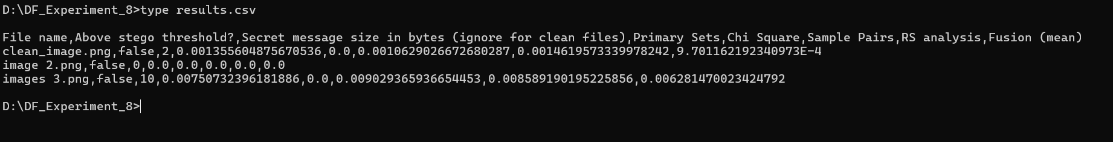
The default StegExpose threshold used in the experiment was 0.2.
All three images produced Fusion scores below 0.2, and the Above stego threshold? field was reported as false for all three images.
Screenshot 4— results.csv output and Fusion scores
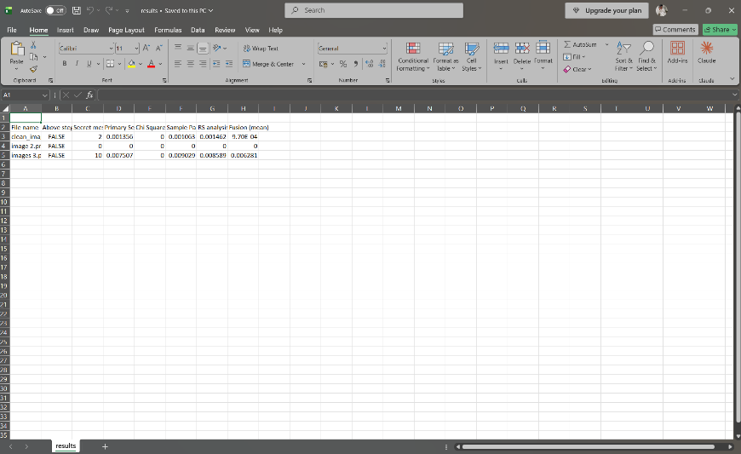
Result
StegExpose was successfully used to perform statistical steganalysis on the three test images. The generated results.csv file provided the statistical analysis values and Fusion scores.
All three images were reported as False under Above stego threshold?, indicating that none of the analyzed images exceeded the configured StegExpose threshold of 0.2.

